Real-Time Industrial Sensor Data Pipeline
Architecture, Implementation, and Production Scalability Report

1. Executive Summary
This project implements an automated, real-time data engineering pipeline designed to ingest, validate, transform, and store continuous time-series data from manufacturing sensors. Simulating a real-world Industrial Internet of Things (IIoT) environment, the system continuously monitors for incoming data streams, strictly enforces data integrity rules, calculates statistical metrics on the fly, and loads the cleaned data into a relational database for downstream analytics.

Dataset Link : https://www.kaggle.com/datasets/ziya07/smart-manufacturing-iot-cloud-monitoring-dataset
File Contents:
Timestamps – Time at which the sensor readings were recorded
Machine ID – Unique identifier for each machine
Sensor Readings – Temperature, Vibration, Humidity, Pressure, Energy Consumption
Machine Status – Indicates whether the machine is Idle, Running, or in Failure
Anomaly Flags – Identifies extreme values in temperature and vibration
Predicted Remaining Life – Estimated time before maintenance is needed
Failure Type – The reason for machine failure (e.g., Overheating, Vibration Issue)
Downtime Risk Score – Probability of machine breakdown
Maintenance Required (maintenance_required) – Target column (0 = No, 1 = Yes)

2. Architecture & System Design
The current pipeline is built using Python and follows a robust Extract, Transform, Load (ETL) event-driven architecture.

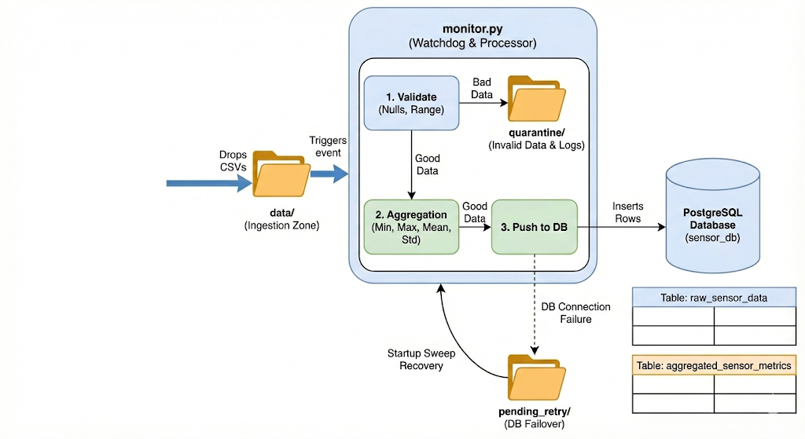

2.1. Ingestion Zone (Event-Driven)
Instead of relying on scheduled batch jobs (cron), the pipeline utilizes an event-driven approach. The watchdog library continuously monitors a designated data/ directory. When a simulated sensor batch (CSV) arrives, the pipeline triggers instantly, ensuring near real-time processing with zero idle latency.
2.2. Processing & Gatekeeper Logic (Pandas)
Incoming data passes through a strict gatekeeper function to ensure database integrity:
- Completeness Checks: Any batch containing null or missing values in critical columns is instantly rejected.
- Boundary Enforcement: Data must fall within physical, real-world boundaries (e.g., Temperature between -50°C and 50°C, Humidity 0-100%).
- Transformations: Standardizes units (Fahrenheit to Celsius) and parses string timestamps into standardized datetime objects.
- Aggregation: Calculates minimum, maximum, mean, and standard deviation metrics for each machine within the batch.
2.3. Storage (PostgreSQL)
The pipeline utilizes SQLAlchemy to sink both the granular raw data and the aggregated metrics into structured PostgreSQL tables (raw_sensor_data and aggregated_sensor_metrics). This structured backend makes the data immediately available for Business Intelligence tools.

3. Fault Tolerance & Data Integrity
To ensure the pipeline is robust enough for continuous operation without manual intervention, two critical safety mechanisms are embedded:
- Database Failover (pending_retry): If the PostgreSQL database goes offline, the system does not crash or drop data. It retries the connection 3 times. Upon ultimate failure, the data is safely routed to a local pending_retry queue while the pipeline continues monitoring for new files.
- Startup Sweep Recovery: If the monitor script itself restarts, it executes a pre-flight sweep of the directory to ingest any data that accumulated while the system was offline, ensuring zero data loss.
- Quarantine System: Corrupted or out-of-bounds files are isolated in a quarantine/ directory, and exact failure reasons are appended to an error_log.txt for easy debugging.

4. Production Scalability: The Serverless GCP Architecture
While the current architecture successfully demonstrates core data engineering principles locally, a production environment requires high availability and cloud scalability. To scale this pipeline without adding the operational overhead of managing clusters (like Apache Spark), I would implement a fully serverless architecture using Google Cloud Platform (GCP).
This approach maps directly to the local pipeline's logic but leverages managed cloud services for infinite scalability:
4.1. Cloud Storage (Replacing the Local Directory)
- Instead of dropping CSV files into a local data/ folder, the factory sensors would upload their payload files directly into a Google Cloud Storage (GCS) bucket. GCS provides virtually unlimited storage and acts as the highly durable entry point for the pipeline.

4.2. Cloud Functions (Replacing the Watchdog Monitor)
- Monitoring a local folder with a Python while loop does not scale. I would migrate the validation, transformation, and aggregation logic into a Google Cloud Function. Cloud Functions are event-driven, meaning the exact moment a new CSV lands in the GCS bucket, the cloud automatically spins up the Python script to process it. This completely eliminates the need for manual server management and scales instantly, whether 1 file or 10,000 files arrive simultaneously.

4.3. BigQuery (Replacing PostgreSQL)
- While PostgreSQL is excellent for transactional data, analytics on massive historical datasets require a columnar data warehouse. The Cloud Function would sink the cleaned data and metrics directly into Google BigQuery. BigQuery is a fully managed, serverless enterprise data warehouse capable of querying petabytes of data in seconds, making it the perfect backend for connecting to BI tools like Tableau or Power BI.

4.4. Dead-Letter Storage (Replacing the Quarantine Folder)
- If the Cloud Function detects null values or out-of-bounds metrics, it will route the invalid CSV file to a separate "Quarantine" GCS Bucket rather than a local folder. This preserves the bad data for auditing by data quality teams without interrupting the main pipeline.

5. Local Setup & Execution Instructions
5.1. Prerequisites
- Python 3.8 or higher.
- PostgreSQL installed and running locally on port 5432.
- A new, empty PostgreSQL database named sensor_db.
5.2. Project Structure
Ensure your project directory is organized exactly as follows:
- /src/monitor.py
- /data (Empty directory for incoming files)
- /quarantine (Empty directory for invalid data)
- /pending_retry (Empty directory for database failover)
- smart_manufacturing_data.csv (The source historical dataset)
- requirements.txt

5.3. Install Dependencies
Open your terminal at the root installed all required python libraries
5.4. Configure Database Credentials
Open src/monitor.py. Locate the Database Configuration section near the top of the file and update the DB_PASSWORD variable to match your local PostgreSQL password.
5.5. Running the Pipeline
This system requires terminal to run src/monitor.py then put put dataset in data/ folder and then pipeline will start.

6. Results

6.1 Screenshots of created Table
